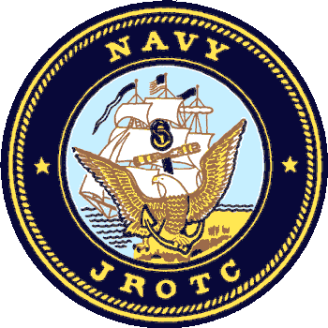

09 September 2021

Dear Friends of Carolina Forest High School NJROTC,

The Carolina Forest High School NJROTC Booster Club is committed to preparing 9th -12th grade students for academic excellence in high school and to become self-confident, lifelong learners who embody the Navy Core Values of Honor, Courage and Commitment. Although we receive funding from the U.S. Navy, these monies only cover uniforms, textbooks, and teaching aides; **it does not cover the costs for extracurricular events**. As such, we rely on community support to enable our program to offer cadets the opportunity to go on field trips, college visits, base tours, and leadership camps. Your involvement will enable our unit to subsidize the cost of these activities, creating opportunities or cadets who might not otherwise be able to participate. Our unit has flourished due to support from our community; we have been an award-winning unit for the past five years in a row and were recognized as the #1 Navy JROTC Unit in South Carolina last year.

We are now preparing for our 1st Ever Annual Dinner and Silent Auction to be held on Saturday, Nov 13, 2021. We have made arrangements to host the event at the Myrtle Beach Moose Lodge located at 479 Burcale Road, Myrtle Beach, SC, 29579. (Ph: 843-236-2990). This event is the primary fundraising activity for our NJROTC Unit each year.  This year, our Dinner Auction will be a celebration with unique opportunities to win many exciting prizes to benefit.

We are currently seeking donations for our Silent Auction. We are asking for your support in order to make this year a success by donating an auction item and/or service, or through purchasing ad space in one of our Social Media accounts. Social Media outlets are a growing source of revenue for many non-profit organizations, and our goal is to amass 1,000 followers this semester. You can become an individual or corporate sponsor.

If you (or someone you know) owns a business, please consider donating auction items and/or services or placing an ad in the program. Community support is critical, and we appreciate your support of our mission. All gifts are tax deductible.

Chief Gregg Thompson is our designated POC for this event. (W: 843-903-7512, email: [gthompson002@horrycountyschools.net](mailto:gthompson002@horrycountyschools.net).) Please contact him with any questions or assistance offers.

On behalf of all our students, parents, and faculty at Carolina Forest High School NJROTC, we thank you for your willingness to consider a donation.

Sincerely,

  
CAPT. Kevin P. Boyle, USN, (ret)  
Carolina Forest Navy JROTC

700 Gardner Lacy Rd,

Myrtle Beach, SC,29579