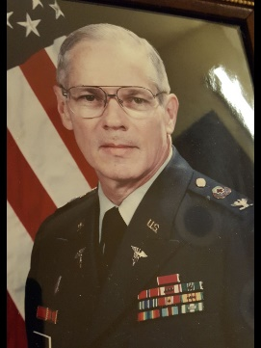
Colonel Robert T. Hawkins, USA (Ret) 11 Apr 1942 - 6 Sep 2018
Retired Army Colonel and former Director of the Indiana Veterans Home, Robert T. (Bob) Hawkins, born on April 11, 1942 in Indianapolis, IN passed away on Sunday, September 2, 2018.
He was the son of the late Mr. & Mrs. A. Floyd Hawkins and brother of the late A. Floyd Hawkins, Jr. He is survived by his wife Fran; daughter Robin and son-in-law Mike Pineda and granddaughters Liliann and Parker; brother-in-law Dick Bennett and Anita; sister-in-law, Esther Benton and several nieces and nephews.
He was an active member of his community, volunteering in numerous organizations to promote the needs of veterans and others. He received the Volunteer of the Year Award for the city of Myrtle Beach as well as the Strom Thurmond Distinguished Public Service Award from the American Legion.
During his twenty eight years of service in the Army, he received numerous accommodations including: The Bronze Star for service in Vietnam, The Legion of Merit (with 2 Oak Leaf clusters), Meritorious Service Medal (with 4 Oak Leaf clusters), Army Commendation Medal (with 4 Oak Leaf clusters), and Order of Military Medical Merit.
He touched the lives of many individuals and will be missed.

