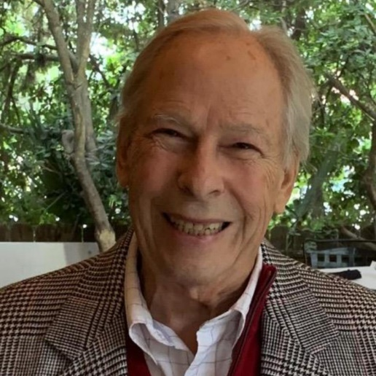

Obituary for George "Gerry" Rhodes Sherwin

George Rhodes “Gerry” Sherwin, 81, died on June 8, 2022 in Murrells Inlet, SC, at home with
family, friends, and hospice care. Gerry was born May 8, 1941 in Worcester, MA, son of George
Alfred and Helen Anna (Rohn) Sherwin.

Gerry graduated from Wachusett Regional High School, Holden Massachusetts in 1959 and
Hamilton College, Clinton, NY in 1963. He joined the Navy and graduated from the U.S. Naval
Officer Candidate School, Newport, RI in 1964. Gerry served 5 years Active Duty on the USS
Havre, USS Mazama, and at the U.S. Naval Communications School, Newport, RI, followed by
19 more years in the U.S. Naval Reserve Military Sealift Command, primarily in Boston and
Rhode Island. He retired with the rank of Captain on the deck of the USS Constitution “Old
Ironsides” in Boston in 1987. It was his honor to serve in the Naval Reserve, helping to preserve
the military readiness of the United States, and he was privileged to enjoy many interesting duty
stations for his annual Active Duty, including San Francisco, New Orleans, Cape Canaveral,
Washington, D.C., and London, England.

Gerry enjoyed a long successful career in banking in Boston and Worcester, MA before moving
to Plattsburgh, NY in 1992, where he served as Senior Vice President at Champlain National
Bank. He enjoyed some of his best years in Plattsburgh on Lake Champlain, where he could
sail, golf, ski at Whiteface Mountain in Lake Placid, and have dinners in nearby Montreal. Since
moving to Murrells Inlet, SC in 2007, Gerry has loved living and playing golf at Wachesaw
Plantation. He found a new opportunity for his life-long musical interest by singing Barbershop
with the Low Country Chorus for many years. Gerry was a member of Unity Myrtle Beach
Church, where he felt that he found his spiritual center.

Throughout his career, Gerry’s respect and commitment were evident in the way he listened and
provided creative solutions for businesses seeking loans. He enjoyed mentoring and helping
others to succeed, and this was recognized by the U.S. Small Business Administration
Syracuse District Office shortly before he retired.

Gerry enthusiastically gave his time and talent to help any organization in which he was
involved. His insight and leadership were recognized by the Boards on which he served,
including as Board Chairman for Mountain Lake PBS and The Development Corporation of
Clinton County in Plattsburgh, NY. Gerry chaired Annual Fund Campaigns for both The
Foundation of Champlain Valley Physicians Hospital Medical Center and The United Way. He
was also a long time member of the Plattsburgh Rotary Club, for which he served as President
and received the Paul Harris Fellow Award. After retirement, Gerry continued to participate on
committees and boards for Wachesaw Plantation Club, Military Officers Association of America,
Low Country Chorus, and Unity MB Church. Service was very important to him.

Gerry met his wife Jane in the summer of 1963 when they both worked at Filene’s Department
Store in Worcester, MA, just before he entered the U.S. Naval Officer Candidate School and
Jane began her first year at UMASS Amherst, School of Nursing. They celebrated their 55th
anniversary on January 21, 2022.

Gerry’s family was his most important treasure. He loved deeply and he was truly loved in
return. His work and commuting took him away for long hours of the day, but he would still make
time to attend school and community events with his sons. In later life, he told anyone who
would listen about his granddaughter Morgan’s musical performances and her role as Tinkerbell
at Disney World, including pictures! He often spoke about how proud he was of his grandson
Logan’s classical piano skills, sharing videos of Logan’s performances. He was greatly
disappointed that health issues and Covid prevented him from meeting his great granddaughter,
Ella Marie, born three years ago in Texas.

Gerry’s friends remember him as a true gentleman, as ethical as the day is long and equally as
generous. He cared about making life better for those in need. He enjoyed good food––a big
lobster paired with a nice wine. And while his golf swing might have been a bit unorthodox, he
loved the game and the countless friends he made on the courses he played. He will be missed.

Survivors include his wife, Jane Alicia (Stumpf) Sherwin; two sons, G. Marcus Sherwin, (wife
Marina and son Logan), North Grafton MA; David T. Sherwin, Worcester, MA, his daughter,
Morgan Elizabeth (Sherwin) Hamilton, (husband Alex), and great granddaughter, Ella Marie
Hamilton) New Braunfels, TX. Gerry leaves three sisters: Anne S. Neary (husband James),
Bluffton, SC, Jane S. Greenslit, Stratham, NH, and Lynn S. Crystoff, Worcester, MA. In addition,
his sisters-in-law, Nancy E. Shivick (husband Richard), Rochdale, MA and North Port, FL, and
Katharine M. Harper (husband Gary) of Tenants Harbor, Maine. He has several nieces and
nephews, and a cousin, Herb Sherwin (wife Roxanna) of Huntsville, AL. Gerry also leaves his
two beautiful Ragdoll cats, Danny and Hobbes, who greatly miss him!

